**Task- 1**

**Aim: Create an app as shown in below image.**

**Program:**

import 'package:flutter/material.dart';

void main() {

runApp(

MaterialApp(

debugShowCheckedModeBanner: false,

home: Scaffold(

backgroundColor: Colors.black,

appBar: AppBar(

title: const Text("Dark Shadow Button"),

centerTitle: true,

backgroundColor: Colors.redAccent,

),

body: Align(

alignment: Alignment.center,

child: Container(

width: 210,

height: 60,

decoration: BoxDecoration(

color: Colors.black,

borderRadius: const BorderRadius.all(

Radius.circular(15),

),

border: Border.all(

color: Colors.redAccent,

width: 1,

),

boxShadow: const <BoxShadow>[

BoxShadow(

blurRadius: 18,

spreadRadius: 4,

color: Colors.redAccent,

),

],

),

alignment: Alignment.center,

child: const Text(

"Tap",

style: TextStyle(

fontSize: 22,

color: Colors.white,

),

),

),

),

),

),

);

}

**Output:**

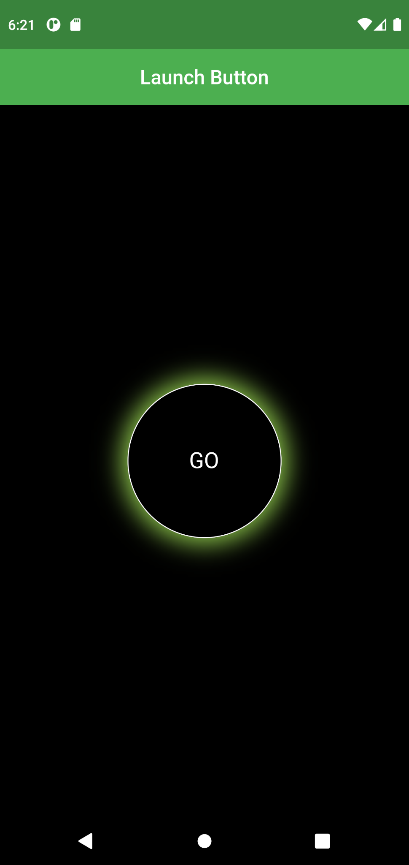

**Task- 2**

**Aim: Create an app as shown in below image.**

**Program:**

import 'package:flutter/material.dart';

void main() {

runApp(

MaterialApp(

debugShowCheckedModeBanner: false,

home: Scaffold(

backgroundColor: Colors.black,

appBar: AppBar(

title: const Text("Launch Button"),

centerTitle: true,

backgroundColor: Colors.green,

),

body: Align(

alignment: Alignment.center,

child: InkWell(

onTap: () {},

splashColor: Colors.white.withOpacity(0.5),

borderRadius: BorderRadius.circular(150),

child: Ink(

child: Container(

width: 155,

height: 155,

decoration: BoxDecoration(

color: Colors.black,

border: Border.all(

color: Colors.white,

width: 1,

),

boxShadow: const <BoxShadow>[

BoxShadow(

color: Colors.lightGreen,

spreadRadius: 6,

blurRadius: 20,

),

],

borderRadius: const BorderRadius.all(

Radius.circular(150),

),

),

alignment: Alignment.center,

child: const Text(

"GO",

style: TextStyle(

fontSize: 22,

color: Colors.white,

),

),

),

),

),

),

),

),

);

}

**Output:**

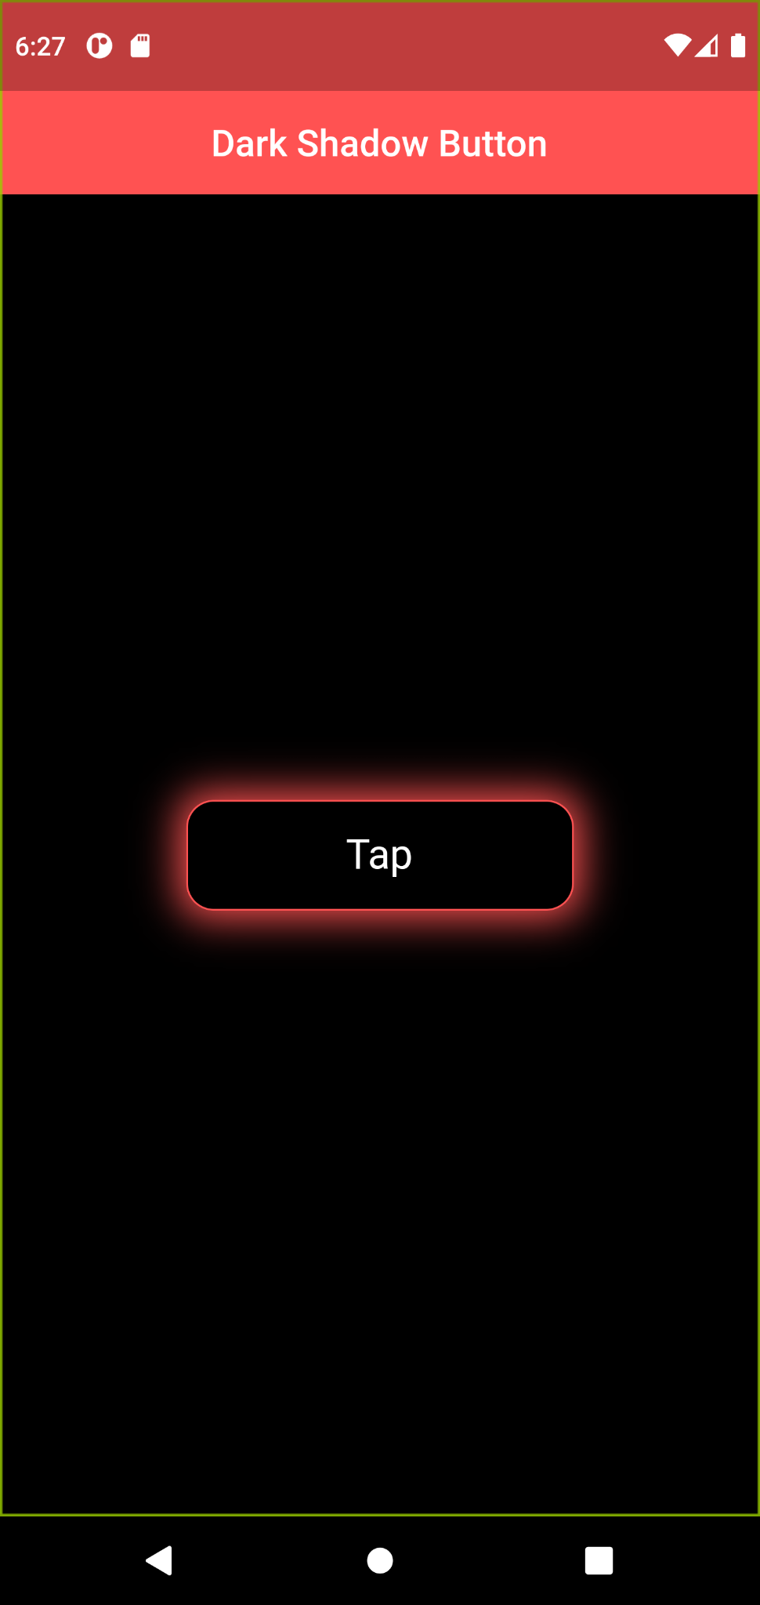

**Task- 3**

**Aim: Create an app as shown in below image.**

**Program:**

import 'package:flutter/material.dart';

void main() {

runApp(

MaterialApp(

debugShowCheckedModeBanner: false,

home: Scaffold(

appBar: AppBar(

title: const Text("A Shadow Button"),

centerTitle: true,

backgroundColor: Colors.teal,

),

body: Align(

alignment: Alignment.center,

child: InkWell(

onTap: () {},

borderRadius: BorderRadius.circular(20),

splashColor: Colors.blue.withOpacity(0.3),

child: Container(

width: 200,

height: 80,

decoration: const BoxDecoration(

color: Colors.white,

borderRadius: BorderRadius.all(

Radius.circular(20),

),

boxShadow: <BoxShadow>[

BoxShadow(

blurRadius: 18,

spreadRadius: 4,

color: Colors.teal,

),

],

),

alignment: Alignment.center,

child: const Text(

"Tap",

style: TextStyle(

fontSize: 25,

fontWeight: FontWeight.bold,

color: Colors.black,

),

),

),

),

),

),

),

);

}

**Output:**

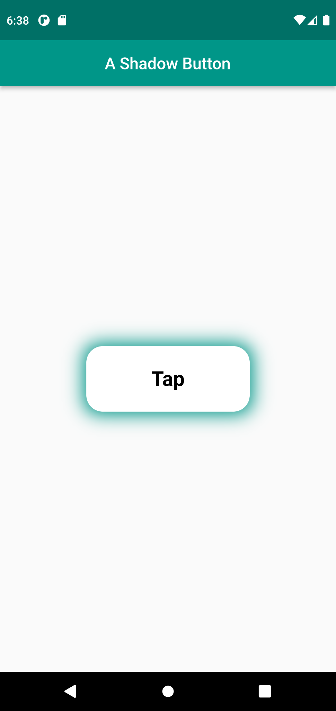

**Task- 4**

**Aim: Create an app as shown in below image.**

**Program:**

import 'package:flutter/material.dart';

void main() {

runApp(

MaterialApp(

debugShowCheckedModeBanner: false,

home: Scaffold(

appBar: AppBar(

title: const Text("Gredient Button"),

centerTitle: true,

backgroundColor: Color(0xff393169),

),

body: Align(

alignment: Alignment.center,

child: Container(

alignment: Alignment.center,

color: const Color(0xff393169),

child: InkWell(

splashColor: Colors.white.withOpacity(0.4),

borderRadius: BorderRadius.circular(30),

onTap: () {},

child: Ink(

child: Container(

width: 200,

height: 75,

decoration: BoxDecoration(

border: Border.all(

color: Colors.white,

width: 1,

),

borderRadius: BorderRadius.circular(30),

gradient: const LinearGradient(

colors: [Colors.purple, Colors.blue],

),

),

alignment: Alignment.center,

child: const Text(

"Flutter",

style: TextStyle(

fontSize: 20,

color: Colors.white,

),

),

),

),

),

),

),

),

),

);

}

**Output:**

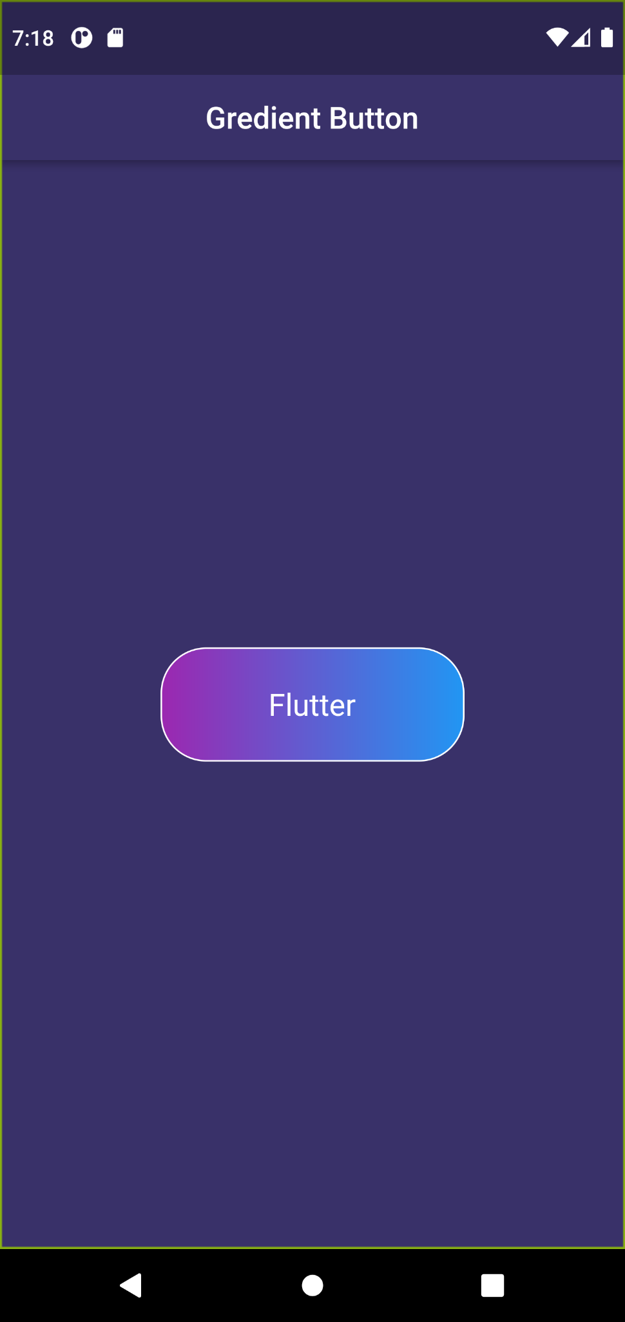

**Task- 5**

**Aim: Create an app as shown in below image.**

**Program:**

import 'package:flutter/material.dart';

void main() {

runApp(

MaterialApp(

debugShowCheckedModeBanner: false,

home: Scaffold(

appBar: AppBar(

title: const Text("An Indian Flag"),

centerTitle: true,

backgroundColor: Colors.blue,

),

body: Align(

alignment: Alignment.center,

child: Container(

alignment: Alignment.center,

decoration: const BoxDecoration(

gradient: LinearGradient(

colors: [

Colors.blue,

Colors.indigo,

],

begin: Alignment.topCenter,

end: Alignment.bottomCenter,

),

),

child: Container(

width: 270,

height: 170,

decoration: BoxDecoration(

gradient: const LinearGradient(

colors: [

Colors.deepOrange,

Colors.white,

Colors.green,

],

begin: Alignment.topCenter,

end: Alignment.bottomCenter,

),

border: Border.all(

width: 1.5,

color: Colors.white,

),

),

alignment: Alignment.center,

child: Text(

"✳",

style: TextStyle(

fontSize: 50,

fontWeight: FontWeight.bold,

color: Colors.deepPurple.shade900,

),

),

),

),

),

),

),

);

}

**Output:**

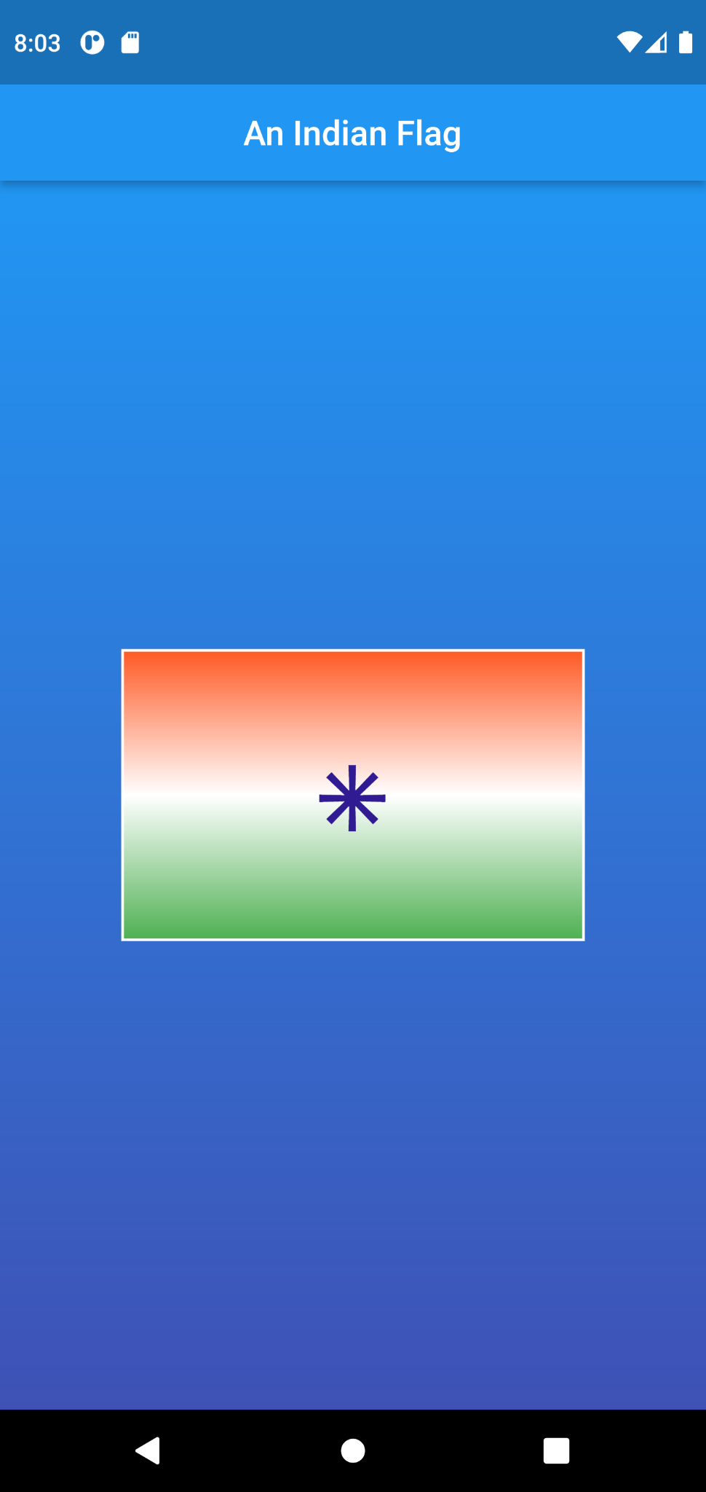

**Task- 6**

**Aim: Create an app as shown in below image.**

**Program:**

import 'package:flutter/material.dart';

void main() {

runApp(

MaterialApp(

debugShowCheckedModeBanner: false,

home: Scaffold(

appBar: AppBar(

title: const Text("Watch"),

backgroundColor: const Color(0xff504766),

),

body: Container(

decoration: const BoxDecoration(

gradient: LinearGradient(

begin: Alignment.topCenter,

end: Alignment.bottomCenter,

colors: [

Color(0xff504766),

Colors.blue,

],

),

),

alignment: Alignment.center,

child: Container(

width: 200,

height: 75,

decoration: BoxDecoration(

boxShadow: <BoxShadow>[

BoxShadow(

color: Colors.black.withOpacity(0.2),

blurRadius: 8,

spreadRadius: 1,

offset: const Offset(5, 5),

),

],

gradient: LinearGradient(

colors: [

Colors.blue.withOpacity(0.3),

Color(0xff504766).withOpacity(0.3),

],

),

borderRadius: BorderRadius.circular(30),

border: Border.all(

width: 0.8,

color: Colors.white.withOpacity(0.2),

)),

alignment: Alignment.center,

child: const Text(

"Flutter",

style: TextStyle(

fontSize: 20,

color: Colors.white,

fontWeight: FontWeight.bold,

),

),

),

),

),

),

);

}

**Output:**

